1. $ cat > file1
then write what you want this will be store in file as well .

2.If you want to create directories inside directories
$ mkdir -p 1/2/3/4
So it will make four directories in above order.

- To delete empty directories
$ rmdir <directory name>

- To delete any directory and file
$ rm -rf <file /dir name> => where f is for force , it will not ask anythings , just delete that file.

- When you want file deletion ask for conformation
$ rm -i <file name>

- $ date => this will give you full information about date and time

And if you want to costumise that date use
$ date +%F => this will show full date
$date +%D: => to show “:” between date and if “/” between date.

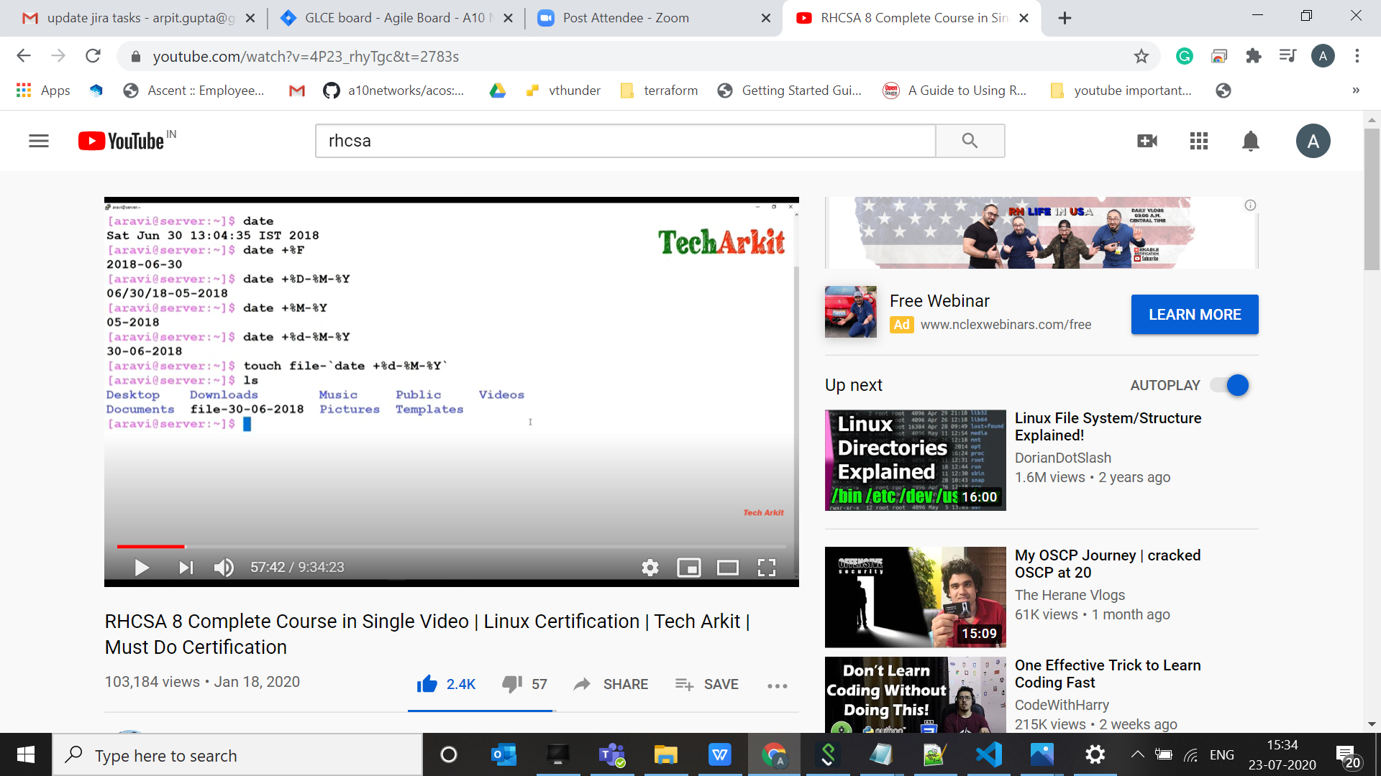

$ touch filename `date +%d-%M-%Y`

$ cat -n file => this will give line number to that file . it doesn’t modify file just print numbers.

$ cat -b file => this will show line number for content only , empty line doesn’t show line number.

To copy all the file for one folder to another

$ cp *.txt /location/

$ cp -pv src dest => this will copy with same properties like 777 and even time as well
pv is preserve the file properties.

if we want to use copy directories , for that we need to do
$ cp -Rv src_dir dest_dir
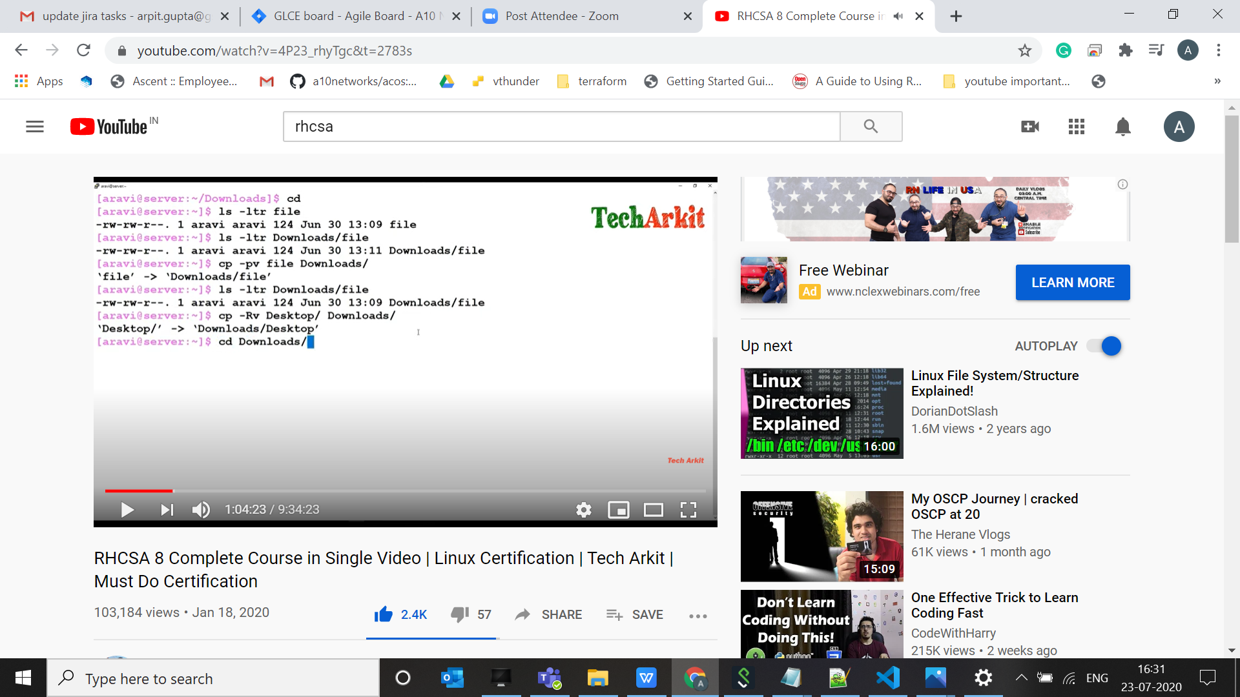

$ mkdir -p dir1/dir2/dir3 => this way we can create multiple directories.

$ df -h => this will show the current partition on your disk.

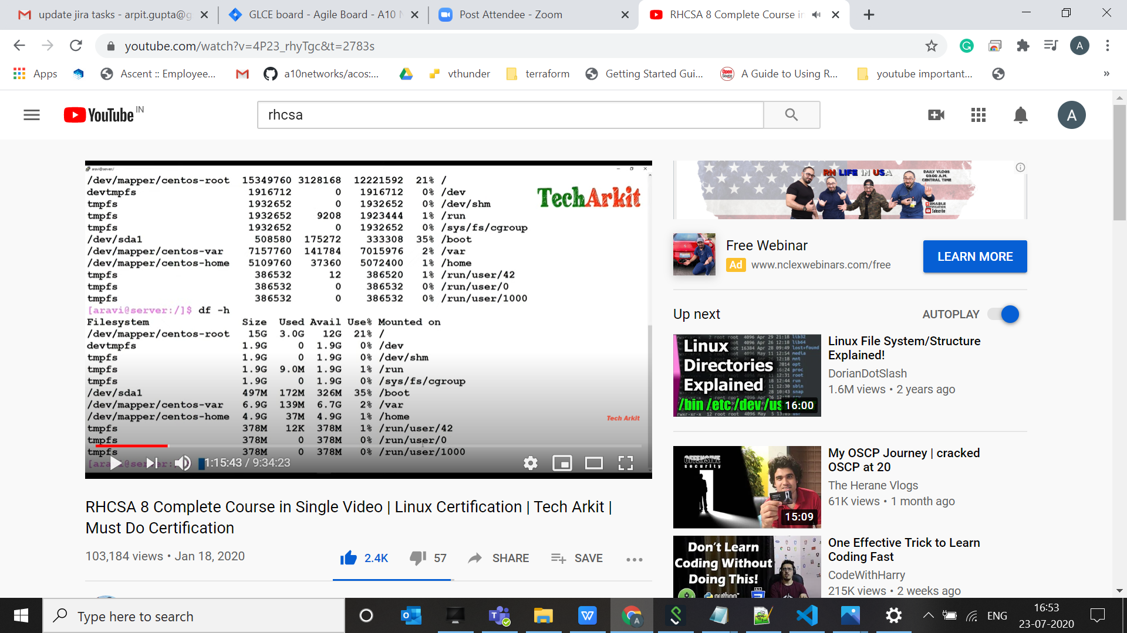

$more => this will allow you to see all content of a big file by pressing “enter”.

Also
$ cat /var/log/message | more

$ who => tells you current login and no of session open .

$who -H => give you information , who log in and when log in .

$ who -a => this will give you all the detail . about login . who login , for which ip and runlevel and all.

$ chmod u+x <filename> => this will change file permission for current user.

$ chmod u+rwx <filename>
$ chmod g+rwx <filename> => this will change permission for group

$ ls -ltr <filename> => this will also show the user owner and group owner of that file
we can change ownership by ch_own ie change chrown command

$ chown username:groupname <filename>


Here in above pic you can see group name change to root

And if you don’t want to change user name just want to group name to be change

$ chgrp <new group name> <filename>

ls -ltr differ.txt
-rw-r--r-- 1 arpit.gupta corp_domain_users 27284 Jul 22 23:34 differ.txt

Here we can see username is “arpit.gupta” and group name is “corp_domain_users”

